

**To all Year 6 & 5 Parents/ Guardians**

**ARTHOG HOODIES- Order form**

**We have sourced Arthog Hoodies from a local supplier this year- Newport Sports.**

**Colours available are below. To have a better look, please go on their website-**

<https://www.our-catalogue.com/NESP/?search=GD57B>

L-R/ TOP-BOTTOM

**BLACK, DARK HEATHER, FOREST GREEN, GRAPHITE HEATHER, GOLD, HELICONIA, IRISH GREEN, LIGHT PINK, MAROON, NAVY, PURPLE, RED, ROYAL BLUE, SPORTS GREY & WHITE**

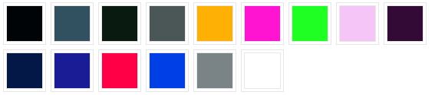



|  |  |
| --- | --- |
| **Childs Name- PLEASE PRINT** |  |
| **Childs initial- CAPITAL LETTERS PLEASE** |  |
| **Colour** |  |
| **Size** |  |

**I can confirm £20 payment will be made via ParentPay by April 7th 2022 and I understand my order will not be processed until payment has been made.**

**Signed Parent/ Guardian ……………………………………………………………… DATE …………………..**

**PLEASE RETURN THIS ORDER FORM TO SUZANNA (Friends) OR TRACEY (School Office).**

**THANK YOU**