Crudgington Primary School Child on Child Abuse Policy 2023-2024

Child on Child Abuse Policy
Date of policy creation | 04.7.2021 |  | Named responsibility | Ames, Adam
Policy last reviewed | 12.12.2023 |  | Named responsibility | LGB

Introduction

The governors, senior leadership team, and all staff (which term shall apply to all volunteer staff members) at Crudgington Primary School (the school) are committed to the prevention, early identification, and appropriate management of child-on-child abuse (as defined below) both within and beyond the school. In particular, we:

  - believe that to protect children, all schools should (a) be aware of the nature and level of risk to which their pupils are or may be exposed and put in place a clear and comprehensive strategy which is tailored to their specific safeguarding context; and (b) take a whole-school community Contextual Safeguarding approach to preventing and responding to child-on-child abuse,

  - regard the introduction of this policy as a preventative measure. We (a) do not feel it is acceptable merely to take a reactive approach to child-on-child abuse in response to alleged incidents of it; and
(b) believe that to tackle child-on-child abuse proactively, it is necessary to focus on all four of the following areas: (i) systems and structures; (ii) prevention; (iii) identification; and (iv) response/intervention,

  - recognise national and increasing concern about this issue, and wish to implement this policy to mitigate harmful attitudes and child-on-child abuse in the school setting, and

  - Encourage parents to hold us to account on this issue so that if their child is feeling unsafe as a result of their peers' behaviour, they should inform the school so that it can ensure that appropriate and prompt action is taken in response.

This Policy

  - is the school's overarching policy for any issue that could constitute child-on-child abuse. It relates to, and should be read alongside, the school's child protection and safeguarding policy and any other relevant policies including, but not limited to, bullying (including cyber-bullying), online safety, acceptable use, data protection and retention of records, children missing in education, pupil behaviour and exclusions.

  - sets out our strategy for improving prevention, identifying, and appropriately managing child-on- child abuse. It is the product of a comprehensive consultation involving pupils, staff and parents and a risk assessment.

  - applies to all governors, the senior leadership team, staff, volunteers, students, and visitors. It is reviewed annually and updated in the interim, as may be required, to ensure that it continually addresses the risks to which pupils are or may be exposed. Several staff and pupils will be involved in each annual review.
  - recognises that abuse is abuse and should never be passed off as 'banter', 'just having a laugh', or 'part of growing up',

  - is compliant with the statutory guidance on child-on-child abuse as set out in Keeping Children Safe in Education (September 2023),

  - does not use the term 'victim' and/or 'perpetrator'. This is because our school takes a safeguarding approach to all individuals involved in concerns or allegations about child-on-child abuse, including those who are alleged to have been abused and those who are alleged to have abused their peers, in addition to any sanctioning work that may also be required for the latter. Research has shown that many children who present with harmful behaviour towards others, in the context of child-on- child abuse, are themselves vulnerable and may have been victimised by peers, parents or adults in the community prior to their abuse of peers,

  - uses the terms' child' and 'children', which is defined for the purposes of this policy as a person aged under 18. We have nonetheless chosen not to restrict our approach to child-on-child abuse under this policy to children but instead to adopt a wider interpretation of our safeguarding responsibilities so that they apply to all pupils, regardless of age. Although the starting point is that the school's response to child-on-child abuse should be the same for all pupils, regardless of age, there may be some different considerations in relation to, for example, a child aged under 10, or a student aged 18 or over in terms of how local agencies and/or partners respond. This, for example, is likely to be different on the part of local authorities, given that their safeguarding duties are limited, in the case of children's social care – save for a number of specific exceptions – to children and, in the case of adult social care services, to adults with care and support needs. Similarly, the school's response to incidents involving the exchange of youth involved sexual imagery will need to differ depending on the age of the pupils involved. There is also likely to be a more significant criminal justice response in relation to any student responsible for abuse who is aged 18 or over,

  - should, if relevant, according to the concern(s) or allegation(s) raised, be read in conjunction with the DfE's advice on Sexual Violence and Sexual Harassment Between Children in Schools and Colleges (DfE's Advice) (May 2018), and any other advice and guidance referred to within it, as appropriate, and

  - should be read in conjunction with the Local Safeguarding Partnership's Safeguarding Policy and Procedures and any relevant Practice Guidance issued by it.

Understanding Child-on-Child Abuse

- What is Child-on-Child Abuse?

  - For these purposes, child-on-child abuse is any form of physical, sexual, emotional, and financial abuse, and coercive control, exercised between children, and within children's relationships (both intimate and nonintimate), friendships and wider peer associations. Child-on-child abuse can take various forms, including (but not limited to): serious bullying (including cyberbullying), relationship abuse, domestic violence and abuse, child sexual exploitation, youth and serious youth violence, harmful sexual behaviour, and/or prejudice-based violence including, but not limited to, gender- based violence.
  - Examples of online child-on-child abuse would include sexting, online abuse, child-on- child grooming, the distribution of youth involved sexualised content, and harassment.

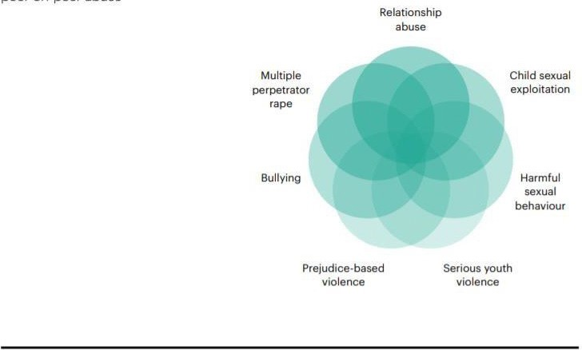
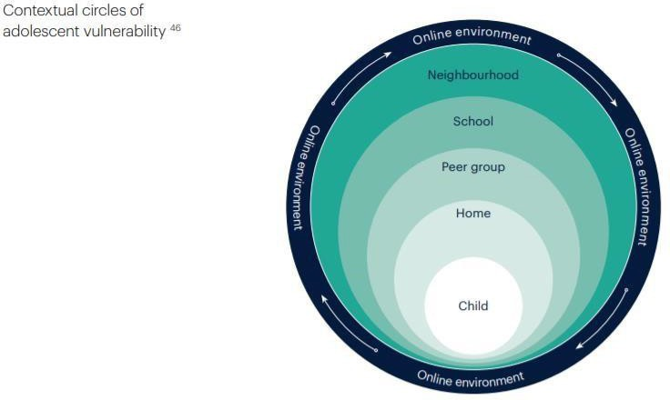

What is Contextual Safeguarding?

  - This policy:

  - encapsulates a Contextual Safeguarding approach, which is about changing the way that professionals approach child protection when risks occur outside of the family, thereby requiring all those within a Local Safeguarding Partnership to consider how they work alongside, rather than just refer into, children's social care, to create safe spaces in which children may have encountered child-on-child abuse.

  - adopts a whole-school community Contextual Safeguarding approach, which means:

  - being aware of and seeking to understand the impact that these wider social contexts may be having on the school's pupils,

  - creating a safe culture in the school by, for example, implementing policies and procedures that address child-on-child abuse and harmful attitudes; promoting healthy relationships and attitudes to gender/ sexuality; hotspot mapping to identify risky areas in the school; training on potential bias and stereotyped assumptions,

  - being alert to and monitoring changes in pupils' behaviour and/or attendance, and

  - contributing to local child protection agendas by, for example, challenging poor threshold decisions and referring concerns about contexts to relevant local agencies (see section entitled 'multi-agency working').

How Prevalent is Child-on-Child Abuse?

  - Research suggests that child-on-child abuse is one of the most common forms of abuse affecting children in the UK. For example, [more than four in ten teenage schoolgirls aged between 13 and 17 in England have experienced sexual coercion. Two-thirds of contact sexual abuse experienced by children aged 17 or under was committed by someone who was also aged 17 or under].

When Does Behaviour Become Problematic or Abusive?

  - All behaviour takes place on a spectrum. Understanding where a child's behaviour falls on a spectrum is essential to being able to respond appropriately to it.

Sexual Behaviours

  - Simon Hackett has proposed the following continuum model to demonstrate the range of sexual behaviours presented by children, which may be helpful when seeking to understand a pupil's sexual behaviour and deciding how to respond to it.

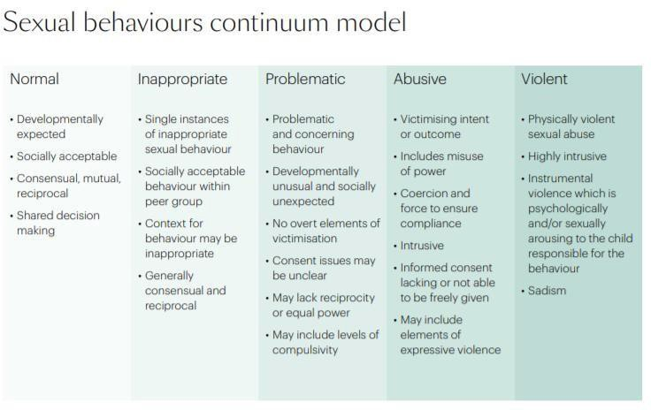

  - Hackett's continuum relates exclusively to sexual behaviours and is not exhaustive. The Brook Sexual Behaviours Traffic Light Tool can help professionals working with children to distinguish between three levels of sexual behaviour – green, amber and red, and to respond according to the level of concern.

Other behaviour

  - When dealing with other alleged behaviour which involves reports of, for example, emotional and/or physical abuse, staff can draw on aspects of Hackett's continuum to assess where the alleged behaviour falls on a spectrum and to decide how to respond. This could include, for example, whether it:
  - is socially acceptable,
  - involves a single incident or has occurred over a period of time,
  - is socially acceptable within the peer group,
  - is problematic and concerning,
  - involves any overt elements of victimisation or discrimination e.g. related to race, gender, sexual orientation, physical, emotional, or intellectual vulnerability,
  - involves an element of coercion or pre-planning,
  - involves a power imbalance between the child/ children allegedly responsible for the behaviour and the child/children allegedly the subject of that power, and
  - involves a misuse of power.

How can a child who is being abused by their peers be identified?

  - All staff should be alert to the well-being of pupils and to signs of abuse and should engage with these signs, as appropriate, to determine whether they are caused by child-on-child abuse.

However, staff should be mindful of the fact that the way(s) in which children will disclose or present with behaviour(s) as a result of their experiences will differ.

Looking behind pupils' behaviour

Case study
A 15-year-old girl starts to exhibit challenging behaviour in class which is out of character. She starts to have disagreements with the girls in her class and a number of "friendship issues" are reported to the teachers. The school moves the girl to another class, changes her timetable so that she does not have to interact with the girls in question, and provides her with a mentor.

A few months later the girl throws a chair across the classroom. The girl is sent to the head teacher who calls the parents and temporarily excludes the girl from school. The pastoral lead discusses the incident with the head teacher, explaining that the behaviour is completely out of character for the girl, and that the school should explore the matter further. The pastoral lead sits down with the girl and asks her how she is. The girl discloses that her boyfriend is being physically violent and verbally abusive towards her.

The school's safeguarding team should regularly review behaviour incident logs which can help to identify any changes in behaviour and/or concerning patterns or trends at an early stage.

Are some children particularly vulnerable to abuse or being abused by their peers?

Any child can be vulnerable to child-on-child abuse due to the strength of peer influence during adolescence, and staff should be alert to signs of such abuse amongst all children. Individual and situational factors can increase a child's vulnerability to abuse by their peers. For example, an image of a child could be shared, following which they could become more vulnerable to child-on-child abuse due to how others now perceive them, regardless of any characteristics which may be inherent in them and/or their family. Peer group dynamics can also play an important role in determining a child's vulnerability to such abuse. For example, children who are more likely to follow others and/or who are socially isolated from their peers may be more vulnerable to peer-on- peer abuse. Children who are questioning or exploring their sexuality may also be particularly vulnerable to abuse by their peers.

  - Research suggests that:

  - child-on-child abuse may affect boys differently from girls, and that this difference may result from societal norms (particularly around power, control and the way in which femininity and masculinity are constructed) rather than biological make-up. Barriers to disclosure will also be different. As a result, schools need to explore the gender dynamics of child-on-child abuse within their settings, and recognise that these will play out differently in single sex, mixed or gender- imbalanced environments,

  - children with Special Educational Needs and/or Disabilities (SEND) are three times more likely to be abused than their peers without SEND, and additional barriers can sometimes exist when recognising abuse in children with SEND.

  - These can include:

− assumptions that indicators of possible abuse such as behaviour, mood and injury relate to a child's disability without further exploration,
− the potential for children with SEND to be disproportionately impacted by behaviours such as bullying and harassment, without outwardly showing any signs,
− communication barriers and difficulties, and
− overcoming these barriers.

Some children may be more likely to experience child-on-child abuse than others as a result of certain characteristics such as sexual orientation, ethnicity, race or religious beliefs.

A whole school Approach

School Environment

  - The school actively seeks to raise awareness of and prevent all forms of child-on-child abuse by:

  - educating all governors, its senior leadership team, staff, pupils, and parents about this issue. This includes: training all governors, the senior leadership team, and staff on the nature, prevalence and effect of child-on-child abuse, and how to prevent, identify, and respond to it. This includes (i) Contextual Safeguarding, (ii) the identification and classification of specific behaviours, including digital behaviours, (iii) the importance of taking seriously all forms of child-on-child abuse (no matter how 'low level' they may appear) and ensuring that no form of child-on-child abuse is ever dismissed as horseplay or teasing, and (iv) social media and online safety, including how to encourage children to use social media in a positive, responsible and safe way, and how to enable them to identify and manage abusive behaviour online. Training includes case studies which the staff design themselves.

  - educating children about the nature and prevalence of child-on-child abuse, positive, responsible and safe use of social media, and the unequivocal facts about consent, via PSHE and the wider curriculum. For example, by reviewing literature in an English class which addresses bullying and its effect on mental health. Pupils are frequently told what to do if they witness or experience such abuse, the effect that it can have on those who experience it and the possible reasons for it, including vulnerability of those who inflict such abuse. They are regularly informed about the school's approach to such issues, including its zero-tolerance policy towards all forms of peer-on- peer abuse. Educating pupils about consent includes teaching them basic facts such as (i) a child under the age of 13 can never consent to any sexual activity; (ii) the age of consent is 16; and (iii) sexual intercourse without consent is rape, and
engaging parents on these issues by:

− talking about them with parents, both in groups and one to one,
− asking parents what they perceive to be the risks facing their child and how they would like to see the School address those risks,
− involving parents in the review of School policies and lesson plans, and

− encouraging parents to hold the school to account on this issue, in part as a result of visibility of this policy.
  - supporting the on-going welfare of the pupils by drawing on multiple resources that prioritise pupil mental health, and by providing in-school ELSA and counselling sessions to address underlying mental health needs. These interventions can be 'de-clinicised' and brokered through a positive relationship with the school and its staff.

  - working with governors, senior leadership team, and all staff, pupils and parents to address equality issues, to promote positive values, and to encourage a culture of tolerance and respect amongst all members of the School community,

  - creating conditions in which our pupils can aspire to, and realise safe and healthy relationships fostering a whole-school culture:

− which is founded on the idea that every member of our School community is responsible for building and maintaining safe and positive relationships, and helping to create a safe School environment in which violence and abuse are never acceptable,
− in which pupils are able to develop trusting relationships with staff, and in which staff understand, through regular discussion and training, the importance of these relationships in providing pupils with a sense of belonging, which could otherwise be sought in problematic contexts,
− in which pupils feel able to share their concerns openly, in a non-judgmental environment, and have them listened to,
− which (i) proactively identifies positive qualities in pupils; (ii) nurtures these qualities; (iii) teaches and encourages pupils to think about positive hopes for the future; and (vi) supports pupils in developing small-scale goals that enable realistic ambitions, and
− which provides supervised activities to pupils that give them the experience of having their needs met that might otherwise apparently be met in abusive circumstances. These can include experiencing (i) status; (ii) excitement; and (iii) a degree of risk,
responding to cases of child-on-child abuse promptly and appropriately, and

  - ensuring that all child-on-child abuse issues are fed back to the school's safeguarding team so that they can spot and address any concerning trends and identify pupils who may be in need of additional support. This is done through direct conversations or concerns recorded on CPOMS, challenging the attitudes that underlie such abuse (both inside and outside the classroom).

Multi-Agency Working

The school actively engages with its Local Safeguarding Partnership in relation to child-on-child abuse, and works closely with, for example, children's social care, the police, Family Connect, Strengthening Families and/or other relevant agencies in accordance with the Local Safeguarding Partnership's procedures, and other schools.
The relationships the school has built with these partners are essential to ensuring that the school is able to prevent, identify early, and appropriately handle cases of child-on-child abuse. They help the school to: (a) develop a good awareness and understanding of the different referral pathways that operate in its local area, as well as the preventative and support services which exist; (b) ensure that its pupils are able to access the range of services and support they need quickly; (c)

support and help inform the school's local community's response to child-on-child abuse; (d) increase the school's awareness and understanding of any concerning trends and emerging risks in its local area to enable it to take preventative action to minimise the risk of these being experienced by its pupils.
The school actively refers concerns and allegations of child-on-child abuse where necessary to children's social care, the police, Family Connect, and/or other relevant agencies in accordance with the Local Safeguarding Partnership's procedures. This is particularly important because peer-on- peer abuse can be a complex issue, and even more so where wider safeguarding concerns exist. It is often not appropriate for one single agency (where the alleged incident cannot appropriately be managed internally by the school itself) to try to address the issue alone – it requires effective partnership working.

Responding to concerns or allegations of child-on-child abuse

General principles

It is essential that all concerns and allegations of child-on-child abuse are handled sensitively, appropriately and promptly. The way in which they are responded to can have a significant impact on our School environment.

Any response should:

  - include a thorough investigation of the concern(s) or allegation(s), and the wider context in which it/they may have occurred (as appropriate) – depending on the nature and seriousness of the alleged incident(s), it may be appropriate for the police and/or children's social care to carry out this investigation,

  - treat all children involved as being at potential risk – while the child allegedly responsible for the abuse may pose a significant risk of harm to other children, s/he may also have considerable unmet needs and be at risk of harm themselves. The school should ensure that a safeguarding response is in place for both the child who has allegedly experienced the abuse, and the child who has allegedly been responsible for it, and additional sanctioning work may be required for the latter,
  - take into account:

− that the abuse may indicate wider safeguarding concerns for any of the children involved and consider and address the effect of wider sociocultural contexts – such as the child's/children's peer group (both within and outside the school); family; the School environment; their experience(s) of crime and victimisation in the local community; and the child/children's online presence. Consider what changes may need to be made to these contexts to address the child/children's needs and to mitigate risk, and

− the potential complexity of child-on-child abuse and of children's experiences, and consider the interplay between power, choice, and consent. While children may appear to be making choices, if those choices are limited, they are not consenting,

− the views of the child/children affected. Unless it is considered unsafe to do so (for example, where a referral needs to be made immediately), the DSL should discuss the proposed action with the child/ children and their parents and obtain consent to any referral before it is made. The school should manage the child/children's expectations about information sharing, and keep them and their parents informed of developments, where appropriate and safe to do so. It is particularly important to take into account the wishes of any child who has allegedly been abused, and to give that child as much control as is reasonably possible over decisions regarding how any investigation will be progressed and how they will be supported.

What should you do if you suspect either that a child may be at risk of or experiencing abuse by their peer(s), or that a child may be at risk of abusing or may be abusing their peer(s)?

If a member of staff thinks for whatever reason that a child may be at risk of or experiencing abuse by their peer(s), or that a child may be at risk of abusing or may be abusing their peer(s), they should discuss their concern with the DSL without delay (in accordance with section 4 of the child protection policy) so that a course of action can be agreed.

Where a child is suffering, or is likely to suffer from harm, it is important that a referral to children's social care (and, if appropriate, the police) is made immediately.
Anyone can make a referral. Where referrals are not made by the DSL, the DSL should be informed as soon as possible that a referral has been made (see Section 5 of the child protection policy).
If a child speaks to a member of staff about child-on-child abuse that they have witnessed or are a part of, the member of staff should listen to the child and use open language that demonstrates understanding rather than judgement. For further details please see the procedures set out in section 5 of the child protection policy.

How will the school respond to concerns or allegations of child-on-child abuse?

The DSL will discuss the concern(s) or allegation(s) with the member of staff who has reported it/them and will, where necessary, take any immediate steps to ensure the safety of the child/all children affected.

Where any concern(s) or allegation(s) indicate(s) that indecent images of a child or children may have been shared online, the DSL should consider what urgent action can be taken in addition to the actions and referral duties set out in this policy to seek specialist help in preventing the images spreading further and removing the images from the internet.

The Internet Watch Foundation (IWF), for example, has a trained team that can evaluate and remove illegal images from the internet when the images are reported to them quickly. They will also share the image with the National Crime Agency's CEOP Command to facilitate an investigation. Any report to IWF will be made in consultation with the police.

DSLs should always use their professional judgement to: (a) assess the nature and seriousness of the alleged behaviour, and (b) determine whether it is appropriate for the alleged behaviour to be to be dealt with internally and, if so, whether any external specialist support is required.
In borderline cases the DSL may wish to consult with children's social care and/or Family Connect and/or other relevant agencies in accordance with the Local Safeguarding Partnership's procedures on a no-names basis (where possible) to determine the most appropriate response.
Where the DSL considers or suspects that the alleged behaviour in question might be abusive or violent on a spectrum or where the needs and circumstances of the individual child/children in question might otherwise require it, the DSL should contact children's social care and/or the police immediately and, in any event, within 24 hours of the DSL becoming aware of the alleged behaviour. The DSL will discuss the concern(s) or allegation(s) with the agency and agree on a course of action, which may include:
A. Manage internally with help from external specialists where appropriate and possible.

Where the alleged behaviour between peers is abusive or violent (as opposed to inappropriate or problematic – unless as stated above), scenarios B, C or D should ordinarily apply. However, where support from local agencies is not available, the school may need to handle concerns or allegations internally. In these cases, the school will engage and seek advice from external specialists (either in the private and/or voluntary sector).
B. Undertake/contribute to an inter-agency early help assessment, with targeted early help services provided to address the assessed needs of the child/children and their family.

These services may, for example, include family and parenting programmes, responses to emerging thematic concerns in extra familial contexts, a specialist harmful sexual behaviour team, CAMHS (BeeU) and/or youth offending services.

C. Refer the child/children to children’s social care for a section 17/47 statutory assessment.

Where a child is suffering, or is likely to suffer from harm, it is important that a referral to children's social care (and, if appropriate, a report to the police) is made immediately. This referral will be made to children's social care in the area where the/each child lives. Depending on the safeguarding procedures issued by the Local Safeguarding Partnership in that area, there will normally be an initial review and assessment of the referral, in accordance with that area's assessment framework. As a matter of best practice, if an incident of child-on-child abuse requires referral to and action by children's social care and a strategy meeting is convened, then the school will hold every professional involved in the case accountable for their safeguarding response, including themselves, to both the/each child who has experienced the abuse, and the/each child who was responsible for it, and the contexts to which the abuse was associated.
D. Report alleged criminal behaviour to the police.

Alleged criminal behaviour will ordinarily be reported to the police. However, there are some circumstances where it may not be appropriate to report such behaviour to the police. For example, where the exchange of youth involved sexual imagery does not involve any aggravating factors. All concerns or allegations will be assessed on a case-by-case basis, and in light of the wider context.

Safety Plans

The school will always carry out a safety plan in respect of:

  - any child who is alleged to have behaved in a way that is considered to be abusive or violent,

  - any child who has reportedly been abused or affected by the alleged abusive or violent behaviour by another child, or

  - any child who may be at risk due to the alleged abusive or violent behaviour by another child as deemed appropriate by the DSL.

Where it is alleged that a child has behaved in a way that is considered to be inappropriate or problematic (as opposed to abusive or violent), the DSL will use their professional judgment – based on the particular concern(s) and/or allegation(s) raised, and the needs and circumstances of the individual child/children in question – to determine whether (as explained above) it would be appropriate to contact children's social care, and to carry out a safety plan.

Careful judgment and consideration are required as to whether alleged behaviour which might be judged to be inappropriate by an adult might actually be harmful to another child. Consultation is recommended with children's social care if there is any doubt about this. Careful consideration should also be given to a range of factors (which are outlined in Appendix B), including the context, severity of the alleged behaviour, impact of the alleged behaviour on others, risk to others, and whether there are any patterns of behaviour occurring.

Where other children have been identified as witnesses to alleged abuse or violence, consideration should also be given by the DSL to whether there might be any risks to those children, and whether a safety plan would be appropriate in relation to any risks presenting to them.

Information sharing, data protection and record keeping

When responding to concern(s) or allegation(s) of child-on-child abuse, the School will:
  - always consider carefully, in consultation with children's social care, the police and other relevant agencies (where they are involved), how to share information about the concern(s) or allegation(s) with the student(s) affected, their parents, staff, and other pupils and individuals,
  - record the information that is necessary for the school and other relevant agencies (where they are involved) to respond to the concern(s) or allegation(s) and safeguard everyone involved,
  - keep a record of the legal purpose for sharing the information with any third party, including relevant authorities, and ensure that the third party has agreed to handle the information securely and to only use it for the agreed legal purpose, and

  - be mindful of and act in accordance with its safeguarding and data protection duties, including those set out in Working Together to Safeguard Children (July 2018) and the HM Government advice on Information Sharing (updated in July 2018).

Disciplinary action

The school may wish to consider whether disciplinary action may be appropriate for any child/children involved. However, if there are police proceedings underway, or there could be, it is critical that the school works in partnership with the police and/or children's social care.
Where a matter is not of interest to the police and/ or children's social care, the school may still need to consider what is the most appropriate action to take to ensure positive behaviour management. Disciplinary action may sometimes be appropriate, including to:
ensure that the child/children take(s) responsibility for and realise(s) the seriousness of their behaviour;

demonstrate to the child/children and others that child-on-child abuse can never be tolerated; and ensure the safety and wellbeing of other children.
However, these considerations must be balanced against any police investigations, the child's/children's own potential unmet needs, and any action or intervention planned regarding safeguarding concerns. Before deciding on appropriate action, the school will always consider its duty to safeguard all children in its care from harm; the underlying reasons for a child's behaviour; any unmet needs, or harm or abuse suffered by the child; the risk that the child may pose to other children; and the severity of the child-on-child abuse and the causes of it.

The school will, where appropriate, consider the potential benefit, as well as challenge, of using managed moves or exclusion as a response, and not as an intervention, recognising that even if this is ultimately deemed to be necessary, some of the measures referred to in this policy may still be required. For example, action may still need to be taken by the school in relation to other pupils who have been involved with and/or affected by child-on-child abuse. Exclusion will only be considered as a last resort and only where necessary to ensure the safety and wellbeing of the other children in the school. Engaging in Fair Access Panel Processes to assist with decision-making associated to managed moves and exclusions can also be beneficial. In the event of any managed move, consideration must be given to sharing information with the receiving school regarding the child-on-child abuse in order to allow best protection of children in the new school.
Disciplinary interventions alone are rarely able to solve issues of child-on-child abuse, and the school will always consider the wider actions that may need to be taken, and any lessons that may need to be learnt going forwards, as set out above and below.

On-going proactive work for a whole-school community Contextual Safeguarding approach

The school's response to concerns or allegations of child-on-child abuse should be part of on-going proactive work by the school to embed best practice and in taking a whole-school community Contextual Safeguarding approach (defined above) to such abuse. As such, the school's response can become part of its wider prevention work.
This response may involve the school working with the local authority to undertake, for example, a Contextual Safeguarding school assessment which would fit into a systems approach to Contextual Safeguarding. The response could also include the school asking itself a series of questions about

the context in which an incident of child-on-child abuse occurred in the school, the local community in which the school is based, and the wider physical and online environment – such as:
  - What protective factors and influences exist within the school (such as positive peer influences, examples where child-on-child abuse has been challenged, etc.) and how can the school bolster these?
  - How (if at all) did the school's physical environment or the pupils' routes to and from the school contribute to the abuse, and how can the school address this going forwards, for example by improving the school's safety, security and supervision, or by working with local safeguarding partners to mitigate the risks to pupils' safety whilst travelling to and from the school?
  - How (if at all) did the online environment contribute to the abuse, and how can the school address this going forwards, for example by strengthening the way in which the school encourages positive and safe use of the internet by pupils?
  - Did wider gender norms, equality issues, and/or societal attitudes contribute to the abuse?
  - What was the relationship between the abuse and the cultural norms between staff and pupils, and how can these be addressed going forward?
  - Does the abuse indicate a need for staff training on, for example, underlying attitudes, a particular issue or the handling of particular types of abuse, or to address any victim-blaming narratives from staff?
  - How have similar cases been managed in the past and what effect has this had?
  - Does the case or any identified trends highlight areas for development in the way in which the school works with children to raise their awareness of and/or prevent child-on-child abuse, including by way of the School's PSHE curriculum and lessons that address underlying attitudes or behaviour such as gender and equalities work, respect, boundaries, consent, children's rights and critical thinking and/or avoiding victim-blaming narratives?
  - Are there any lessons to be learnt about the way in which the school engages with parents to address child-on-child abuse issues?
  - Are there underlying issues that affect other schools in the area and is there a need for a multiagency response?
  - Does this case highlight a need to work with certain children to build their confidence, and teach them how to identify and manage abusive behaviour?
  - Were there opportunities to intervene earlier or differently and/or to address common themes amongst the behaviour of other children in the school?
Answers to these questions can be developed into an action plan that is reviewed on a regular basis by the school's leadership and the DSL. The school will, where possible and appropriate, work with the local authority and wider partners to deliver on this plan, possibly as part of a wider Contextual Safeguarding school assessment led by or with input from the local authority.

Appendix A

Local MASH - Family Connect
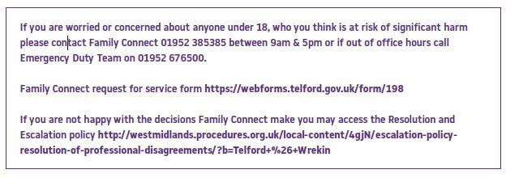
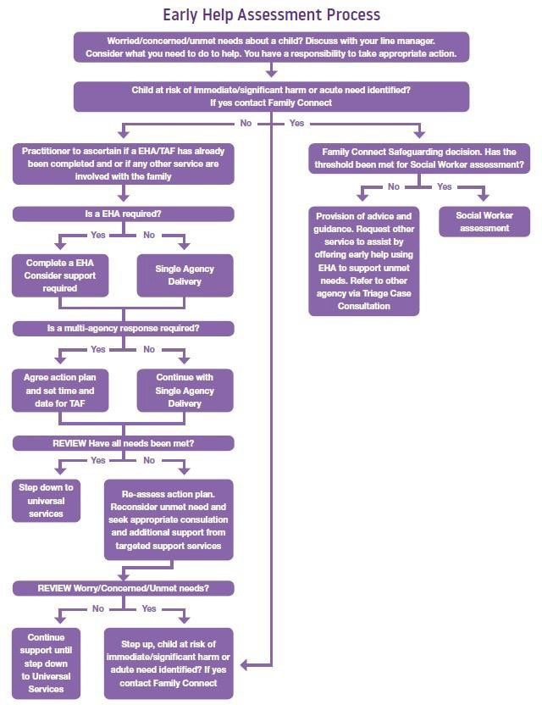

Step up
Request for service to Children's Social Care without EHA/TAF Inplace

Prior tocontacting Famly Connoct Safogunrding Teamtho practitionar NEEDSTO cOll!dt wih thadas1gnatodsafoguardlngloodoffica,of their agency.

Information rolating to thoconccwn prusanted to FamtyConnactSatoguaning, acknowlodong
thatthe fanlyarenotcUl'Rlllttysupportad through o EHA/TAF procoss

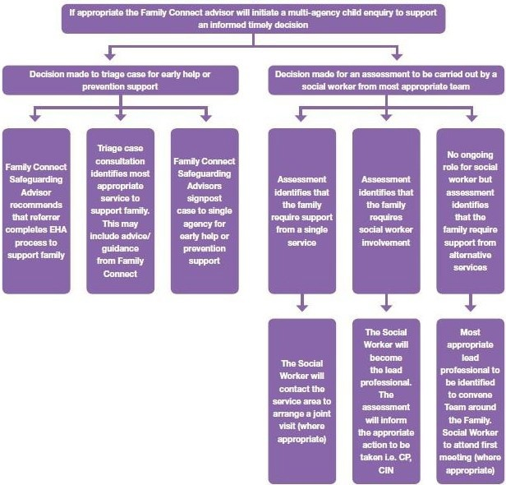
FamilyConlOct Safoguaning Advisor taam wil consider whathor thDthrashold has boanmot
for an intClfVGfltiontromoneof tha childron's socialcarotuarns

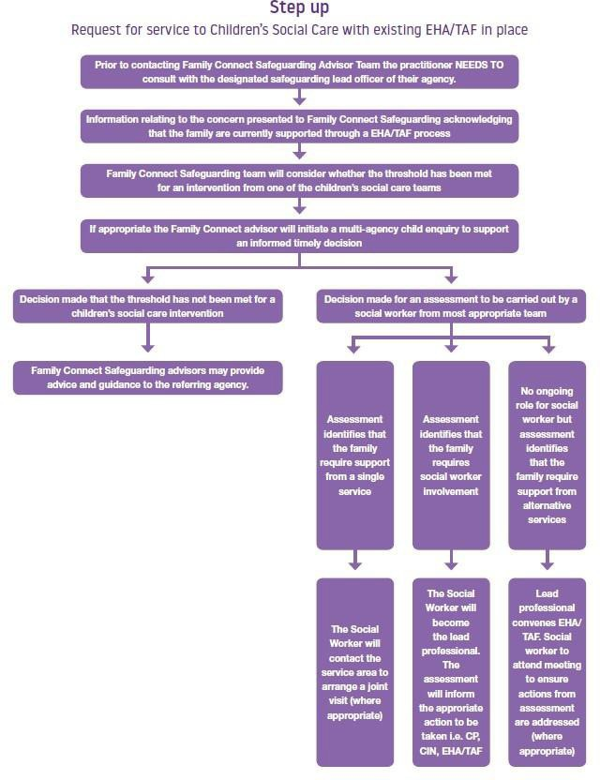

Appendix B

What is child-on-child abuse?

Different types of abuse rarely take place in isolation and often indicate wider safeguarding concerns. For example, a teenage girl may be in a sexually exploitative relationship with a teenage boy who is himself being physically abused by a family member or by older boys. Equally, sexual bullying in schools and other settings can result in the sexual exploitation of children by their peers. For 16 and 17-year-olds who are in abusive relationships, what may appear to be a case of domestic violence may also involve sexual exploitation or coercion. Children's experiences of abuse and violence are rarely isolated events, and they can often be linked to other things that are happening in their lives, and to spaces in which they spend their time. Any response to concerns or allegations of child-on-child abuse therefore needs to consider the range

of possible types of child-on-child abuse set out in a school's child-on-child abuse policy, and to capture the full context of children's experiences. This can be done by adopting a Contextual Safeguarding approach and by ensuring that a school's response to alleged incidents of child-on-child abuse takes into account any potential complexity.

What is Contextual Safeguarding?

Contextual Safeguarding is about changing the way that professionals approach child protection when risks occur outside of the family, thereby requiring all those within a Local Safeguarding Partnership to consider how they work alongside, rather than just refer into, children's social care, to create safe spaces in which children may have encountered child-on-child abuse. In addition, it:

- is an approach to safeguarding children that recognises their experiences of significant harm in extra-familial contexts, and seeks to include these contexts within prevention, identification, assessment and intervention safeguarding activities,
- recognises that, as children enter adolescence, they spend increasing amounts of time outside of the home in public environments (including those online) within which they may experience abuse, and
- considers interventions to change the systems or social conditions of the environments in which abuse has occurred. For example, rather than move a child from a school, professionals could work with the school leadership and student body to challenge harmful, gendered school cultures, thus improving the pre-existing school environment.

Identifying and assessing behaviour

Sexual Behaviour

As the NSPCC explains `children's sexual behaviours exist on a wide continuum, from normal and developmentally expected to highly abnormal and abusive. Staff should recognise the importance of distinguishing between problematic and abusive sexual behaviour. As both problematic and abusive sexual behaviours are developmentally inappropriate and may cause developmental damage, a useful umbrella term is harmful sexual behaviours or HSB.'

This term has been adopted widely in the field, and is used throughout the NSPCC's, Research in Practice's and Professor Simon Hackett's harmful sexual behaviour framework (which should be used alongside the National Institute for Health and Care Excellence (NICE) guidelines on harmful sexual behaviour among young people), as well as the child-on-child abuse policy.

For the purpose of that harmful sexual behaviour framework, and as adopted in the child-on-child abuse policy, harmful sexual behaviours are defined as 'Sexual behaviours expressed by children…that are developmentally inappropriate, may be harmful towards self or others, or be abusive towards another child…or adult.'
Local authorities use a range of assessment and intervention frameworks which can be very helpful in assessing where any given behaviour falls on a continuum. The Assessment Intervention Moving on (AIM2) model is one example.
Staff should always use their professional judgment and discuss any concerns with the DSL. Where an alleged incident involves a report of harmful sexual behaviour, staff should consult the DfE's Advice.

Other behaviour

When drawing on Hackett's continuum, in order to assess the seriousness of other (i.e. non-sexual) alleged behaviour, it should be borne in mind that there are some aspects of Hackett's continuum which may not of course be relevant or appropriate to consider. For example, the issue of consent and the nuances around it, are unlikely to apply in the same way in cases where the alleged behaviour is reported to involve emotional and/or physical abuse, as it could in cases of alleged sexual behaviour which is reported to involve harmful sexual behaviour.

In addition, schools could be required to deal with cases involving a range of alleged behaviours including sexual behaviour, emotional, physical behaviour and digital behaviour.
It should also be recognised that the same behaviour presented by different children may be understood at different points on a spectrum, depending on the particular context. For example, an incident involving youth involved sexual imagery may be inappropriate in one context, for example, when exchanged between two 11-year-old children in a consenting relationship, and abusive in another. For example, when it is (a) shared without the consent of the child in the image; (b) produced as a result of coercion; or (c) used to pressure the child into engaging in other sexual behaviours.

Behaviour which starts out as inappropriate may escalate to being problematic and then abusive, either quickly or over time. Intervening early and addressing any inappropriate behaviour which may be displayed by a child is vital, and could potentially prevent their behaviour from progressing on a continuum to becoming problematic, abusive and/or violent – and ultimately requiring
(greater/more formal) engagement with specialist external and/or statutory agencies. For example, a physical fight between two children may not constitute child-on-child abuse where the fight is a one-off incident but may be abusive where the child's/children's behaviour subsequently deteriorates into a pattern of bullying behaviour and requires a safeguarding response from a multiagency partnership – including a statutory assessment of whether this has led, for example, to a risk of significant harm to a child.

The importance of intervening early and addressing any inappropriate behaviour does not just apply on an individual student basis but could also apply to a cohort of the student body, such as a year group or key stage, or across the student body as a whole.
Behaviour generally considered inappropriate may in fact indicate emerging concerning behaviour to which schools need to take a whole-school approach in order to prevent escalation. For example, where multiple boys are making inappropriate comments about girls, one-off sanctions are unlikely to be effective and wider actions should be considered, such as implementing a bystander intervention model throughout the school or arranging for an external person to deliver a year group intervention exercise; revising the school's RSE programme; and/or a discussion around whether anything is happening within the wider community that might be affecting the pupils' behaviour.

It will also be important to consider the wider context in which the alleged behaviour is reported to have occurred, and which may trigger the need for a referral. For example, some behaviour that is considered inappropriate may be capable of being dealt with internally. However, if there are wider safeguarding concerns relating to the child/children in question, a referral to statutory agencies may be necessary.
Where the behaviour which is the subject to the concern(s)/ allegation(s) is considered or suspected by the DSL to constitute child-on-child abuse, schools should follow the procedures set out in the child-on-child abuse policy.

How can a child who is being abused by their peers be identified?

Signs that a child may be suffering from child-on-child abuse can also overlap with those indicating other types of abuse and can include:

- failing to attend school, disengaging from classes or struggling to carry out school related tasks to the standard ordinarily expected,
- physical injuries,
- experiencing difficulties with mental health and/or emotional wellbeing,
- becoming withdrawn and/or shy; experiencing headaches, stomach aches, anxiety and/or panic attacks; suffering from nightmares or lack of sleep or sleeping too much,
- broader changes in behaviour including alcohol or substance misuse,
- changes in appearance and/or starting to act in a way that is not appropriate for the child's age, and
- abusive behaviour towards others.
Abuse affects children very differently. The above list is by no means exhaustive, and the presence of one or more of these signs does not necessarily indicate abuse. The behaviour that children present with will depend on their particular circumstances.
Rather than checking behaviour against a list, staff should be trained to be alert to behaviour that might cause concerns, to think about what the behaviour might signify, to encourage children to share with them any underlying reasons for their behaviour and, where appropriate, to engage with their parents so that the cause(s) of their behaviour can be investigated. Where a child exhibits any behaviour that is out of character or abnormal for his/her age, staff should always consider whether an underlying concern is contributing to their behaviour (for example, whether the child is being harmed or abused by their peers) and, if so, what the concern is and how the child can be supported going forwards.

The power dynamic that can exist between children is also very important when identifying and responding to their behaviour: in all cases of child-on-child abuse a power imbalance will exist within the relationship. This inequality will not necessarily be the result of an age gap between the child responsible for the abuse and the child being abused. It may, for example, be the result of their relative social or economic status.
Equally, while children who abuse may have power over those who they are abusing, they may be simultaneously powerless to others.

Safety Plans
In deciding (a) whether a safety plan would be appropriate; and (b) which children require a safety plan, the DSL should consider:
- the extent to which a child may have experienced or otherwise been affected by the alleged behaviour, and the impact on them. This will depend not only on the child's involvement in or proximity to the alleged behaviour, but also on factors such as their possible wider circumstances and needs, their age and understanding, and the extent to which the alleged behaviour might trouble or distress other children, or expose them to inappropriate sexual behaviour,
- the importance of early intervention to address and to prevent escalation of inappropriate and/or problematic behaviours, and
- whether there are any wider safeguarding concerns about a child – for example, where a child's behaviour may be considered to be inappropriate or problematic on Hackett's continuum, or at risk of escalating, the DSL and/or external agencies may determine that a safety plan is required to control emerging risks.

In all cases where a safety plan is not considered to be appropriate, the school should nonetheless take steps to safeguard and support the/each child who is allegedly responsible for the behaviour, and any children affected by it, and should continue to monitor the situation. If risks increase, consideration should again be given to developing a safety plan. A safety plan should be developed in consultation with key statutory agencies to whom any referral and/or report is necessary.

In developing a safety plan the school should:

- always have regard to Keeping Children Safe in Education (September 2023), and Working Together to Safeguard Children (July 2018), and make a referral to children's social care and, if appropriate, report to the police, whenever a child has been harmed, is at risk of harm, or is in immediate danger. Where a report of rape, assault by penetration or sexual assault is made, this must be reported to the police. Whenever a referral is made to children's social care and/or a report to the police, the school should inform children's social care and/or the police of the school's need to have a safety plan. Careful liaison with children's social care and/or the police should help the school to develop any such plan,
- consult children's social care and/or Family Connect, and/or other relevant agencies in accordance with the Local Safeguarding Partnership's procedures regarding the concern(s) or allegation(s) and need to have a safety plan, and seek their agreement to the plan whenever possible,
- consult the police, where they are involved, to seek advice, and agreement whenever possible, on the safety plan, and ensure that the safety plan does not prejudice any criminal investigation(s), and that it protects all children involved in any such investigation(s) to the greatest extent possible,
- if an agency is not, for whatever reason, engaging, then the school should advise the agency that it intends to develop a safety plan for the/each child concerned. The school should also consider escalating their referral if they believe children's social care and/or the police should be engaged. The school should share its safety plan with children's social care and the police where they are involved. The safety plan should be consistent with any risk assessments or plans made by children's social care, the police, or any other professionals working with the child,
- give consideration to consulting and involving the/ each child and their parents about the development of their safety plan, in accordance with any advice given by children's social care and/ or the police. Where a report has been made to the police, the school should consult the police, and agree what information can be disclosed to the/each child who is allegedly responsible for the behaviour and their parents. There may be other circumstances where there are legitimate obstacles presented to parental knowledge/engagement – for example, if there is a suggestion or concern that informing the parents will put the/any child at additional risk; in these cases, the school should work closely with children's social care and/or the police to take advice on how best to proceed, and
- a safety planning meeting may be helpful to develop the safety plan. Where such a meeting is to be held, careful consideration will need to be given to whether the child presenting the alleged behaviour, and/or their parents should attend. Where a child or parent does not attend, their wishes and feelings should still be sought in relation to any proposed safety plan in advance of the meeting by a professional – in the case of the child, with a designated trusted professional with whom he/she has a positive relationship. A version of the plan which is appropriate for the child's age and level of understanding should be provided to the child and their parents. Efforts should also be made to ensure that they understand what is proposed and to seek their agreement to the arrangements.

These steps will help to ensure that the safety plan is appropriately tailored to the/each child's needs and will enable the school to work with others in an effort to meet these needs in the longer-term.

A safety plan should:

- be proportionate and not stigmatise the child/ children allegedly responsible for or affected by the behaviour,
- set out relevant background information – including an overview of the context, the specific concern(s) or allegation(s), any relevant detail about the relationships, and any power differentials between the child/children allegedly responsible for the behaviour, and any children affected by it, the frequency of the alleged behaviour and any changes in it over time. Details should also be shared of action taken regarding the alleged concern(s) or allegation(s), and any advice provided by children's social care, and/or Family Connect and/or other relevant agencies in accordance with the Local Safeguarding Partnership's procedures, and/or the police, and/or any other professional(s) working with the child/children,
- set out any relevant information regarding the child/ children concerned. For example, any relevant medical information, any previous concerns about the child's/children's behaviour, needs or harm that the child/children may have been exposed to in the past. Information should be shared on their wishes and feelings regarding the proposed safety plan. Consideration may need to be given to having two or more separate but aligned safety plans for the child who is allegedly responsible for the behaviour, and the child or children affected by it,
- identify and assess the nature and level of risk that is posed and/or faced by the child/children in school such as that which may arise in relation to locations, activities, contact with particular pupils, or transport arrangements to and from school; and contexts outside the school, including at home, in relationships with friends, peer groups, interactions in the neighbourhood and/or during online activity,
- set out the steps and controls that can be put in place to reduce or manage any risk. Issues that may be addressed include:
− how safety will be ensured in the classroom, out of the classroom, on transport, and during unstructured or extra-curricular activities, including trips and residential stays away from school.
This may involve separating the child/ children who present risk from other children who may be affected by the alleged child-on-child abuse,

− how to ensure that the child/children reportedly affected by the alleged behaviour feel(s) supported, including by appointing a trusted member of staff (a 'critical friend') with whom they can speak if they have existing concerns or if there are any future developments which cause them concern,

− how best to draw on any other trusting relationships where these exist, and create them where they do not, to provide the children concerned with support and a sense of belonging,

− where relevant, how to manage the child's/children's behaviour – this can be done in a number of ways including, for example, by way of a de-escalation plan for staff which identifies any triggers, explains how their behaviour can escalate, sets out the function of the behaviour for the child/children, and proposes an appropriate action or response to it; identifying language that should be used and avoided; a positive handling plan; or implementing controls and measures to reduce or manage any risk,

− whether restorative action would be appropriate and, if so, how best to take such action, bearing in mind the specific needs of the child/children concerned, and the appropriateness of any such action given the

nature and seriousness of the concern(s) or allegation(s). Advice should be taken from children's social care, specialist sexual violence services, and the police where they are involved (if so, proposed restorative action could otherwise jeopardise a police investigation),

− whether any targeted interventions are needed to address the underlying attitudes or behaviour of the child/children, any emotional and behavioural disorders, developmental disorders, or learning difficulties, and/or to meet the child's/children's psychological, emotional or physical needs, drawing on local statutory, private and/ or voluntary services as appropriate, and

− whether the behaviour is of such high risk that suitable controls cannot be put in place within the school setting which would enable it to be adequately managed. In this case consideration will need to be given to alternative plans for the child/children presenting the alleged behaviour. The principle that any child who is reported to have experienced child-on-child abuse should not have restrictions or controls placed on them as a result of another child's alleged behaviour should be given priority consideration.

- identify and consider how to build on strengths and positive aspects that the/each child possesses and/or is exposed to, such as those emanating from activities or lessons that the child enjoys and engages with; positive characteristics and skills that the child possesses; and/or trusting relationships with the child's family, other pupils or staff,
- assess any risks that are posed and/or faced by the wider school community (including all other pupils and, where appropriate, staff and parents) and identify any steps that the school can take to mitigate these risks. This may include:
− consideration of how to support any pupils (and, where appropriate, staff and parents) who know about and/or may be affected by the alleged behaviour, and/or who may be required to participate in any investigation(s) – where these pupils have their own standalone safety plan, they should cross refer to and be consistent (where appropriate) with one another, and

− consideration of work that can be undertaken with the wider staff or student population to help to protect children against child-on-child abuse in the future. Careful consideration will need to be given to manging confidentiality for children affected by the alleged behaviour or engaged themselves in any such behaviour.

- set out the steps needed to implement the safety plan, including how to communicate with and what information should be shared with relevant staff members – in the strictest confidence – so that they are able to implement the actions set out in the plan and safeguard the children concerned appropriately, and
- be reviewed at regular intervals, or if there is a change in perceived risks or circumstances. Reviews should be carried out in light of the children's ongoing needs to ensure that real progress is being made which benefits the children concerned.
If at any stage the risk increases, there is a further alleged incident, or any individual child's needs escalate, the DSL should contact children's social care, and/or Family Connect, and/or other relevant agencies in accordance with the Local Safeguarding Partnership's procedures, to determine the appropriate course of action. In the event that any new information is disclosed at any time indicating a child may have been harmed, is at risk of harm, or is in immediate danger, the school should again follow local safeguarding procedures in line with Keeping Children Safe in Education (September 2023), and Working Together to Safeguard Children (July 2018), and make a new referral to children's social care and, if appropriate, report to the police. Similarly, any new information disclosed at any time regarding alleged rape, assault by penetration or sexual assault must always be shared with the police.

